- Missing alt Attributes:
  - The <img> tags should have descriptive alt attributes for better accessibility and SEO.
html
<img src="assets/images/logo.jpeg" width="30" height="30" alt="logo" />
- Form Elements:
  - The <select> elements and <input> fields do not have id or name attributes, which are necessary for form submission and accessibility.
html
<select class="form-select select2-field" name="" id="">
- Button Elements:
  - The <button> elements should have type="button" to prevent them from submitting forms if they are not intended to do so.
html
<button type="button" class="reset-btn">
- Modal Accessibility:
  - The modal should have aria attributes to improve accessibility, such as aria-labelledby and aria-describedby.
html
<div id="viewDwtailModal" class="modal" aria-labelledby="modalTitle" aria-

- Add the following fields on the sign-up.html page. The ones with the * should be required fields:
  - First Name*
  - Last Name*
  - Email*
  - Account Type: Please add a dropdown for User Groups with possible values of Real Estate Agent, Broker, Law Enforcement, Investor and Other. The default classification for a new user is "Real Estate Agent".
  - Language (default to “English”), language options in the dropdown should be English, Spanish, and Portuguese.
  - Currency (default to USD), currency options are USD, BRL,EUROS
  - Username*
  - Password*
- For the sign-in.html page, please make the Username and Password required fields.
- For the sign-in.html page, please add field names before the data entry box: Use Email and Password such as below
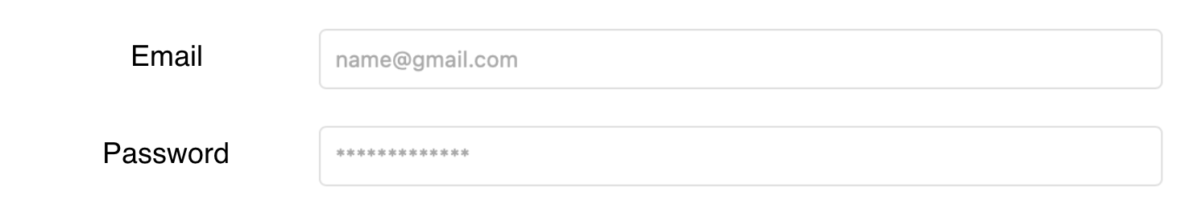
- The current login has a Reset your password option but this is missing from sign-in.html, please add it and we can change the link later.



- Add Download button to the table in the main index.html at the bottom (just like the View Detail Modal box)
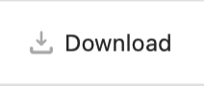
- Fix issue below in the Filter box on the “View Modal” screen. When you click it, it opens but you cannot close it. It needs to close when you click out of the Filter modal box.
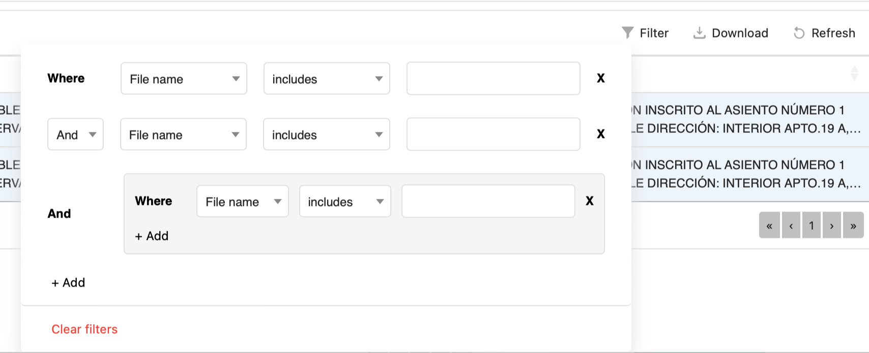
- Data is currently MM/DD/YYYY; however, the date must be DD/MM/YYYY (check the Retool application). Please ensure the dropdown calendar works with DD/MM/YYYY.
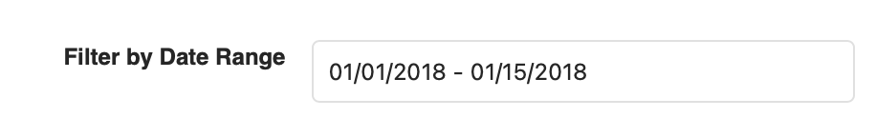

- Please make the field below in to a field that add commas like currency

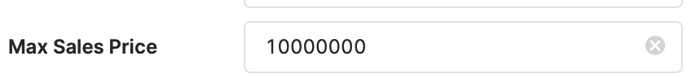

The above value should appear as 1,000,000 as the user enters

- On the first black banner, please add text so we can output the account type (Free, Premium), see below



- Why is it in the View Modal box, when I click on the PDF data it expands as expected, but when I try to copy the text the row collapses/closes? It should remain open allowing me to copy the text until I click on it again which should collapse/close it.

